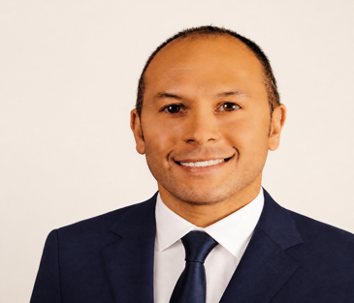


Dr. Jared Wilkinson

PRESS RELEASE Contact: Ashley Torrence, PhD FOR IMMEDIATE RELEASE Dir. of Strategic Communications
July 1, 2026 atorrence@physiciansfootcare.com

PHYSICIANS FOOTCARE WELCOMES DR. JARED WILKINSON
Charleston, SC- Physicians Footcare, the Southeast's premier podiatric practice, is pleased to announce that Dr. Jared Wilkinson will be joining our team on August 3. Dr. Wilkinson brings more than two decades of experience in podiatric medicine and reconstructive foot and ankle surgery, along with an outstanding record of clinical leadership, surgical excellence, and patient-centered care.
Dr. Wilkinson is board certified by the American Board of Foot and Ankle Surgery (ABFAS) in Foot Surgery and Reconstructive Rearfoot and Ankle Surgery and is a Fellow of the American College of Foot and Ankle Surgeons (FACFAS). He completed his residency at Yale New Haven Hospital/VA Connecticut Health Care System, where he served as Chief Podiatric Surgical Resident and received the Yale School of Medicine Academic Achievement Award.
Throughout his distinguished career, Dr. Wilkinson has served as a surgical podiatrist with Northern Light Health System in Maine, where he held numerous leadership roles, including lead physician for the Podiatry and Wound Care Departments, Chief of Staff at Sebasticook Valley Hospital, and a member of the Northern Light Inland Hospital Medical Executive Committee. He has also contributed extensively to podiatric research, medical publications, and professional education.
"I am excited to join Physicians Footcare and look forward to providing exceptional foot and ankle care while helping patients improve their mobility, comfort, and quality of life," said Dr. Wilkinson.
"We are honored to welcome Dr. Wilkinson to the Physicians Footcare team," said Dr. Ray, CEO of Physicians Footcare. "His exceptional surgical expertise, extensive leadership experience, and longstanding commitment to advancing podiatric medicine make him an outstanding addition to our practice. Dr. Wilkinson's reputation for clinical excellence and compassionate patient care aligns perfectly with our mission of delivering the highest quality care to every patient we serve."
To schedule an appointment with Dr. Wilkinson, contact our West Ashley office at (843) 531-6249. To learn more about Physicians Footcare and the array of healthcare services we provide visit www.physiciansfootcare.com.

About Physicians Footcare
Physicians Footcare is one of the largest podiatric practices in the southeast and the nation. It is the Southeast’s premier podiatry practice, independently and privately owned. Since opening our first location in 2006, we have grown to locations in South Carolina, Georgia, and New York. Our mission is simple—To be the Best Medical Practice.

###

